Create Database & Table

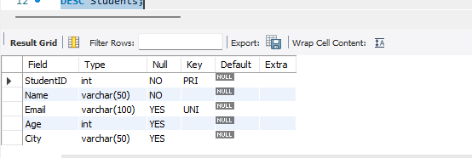
Explanation:
The CollegeDB database and Students table were created successfully with the required columns and constraints.
DESC Students displays the table structure, including column names, data types, and key constraints.

